**DAILY ONLINE ACTIVITIES SUMMARY**

|  |  |  |  |  |  |  |  |
| --- | --- | --- | --- | --- | --- | --- | --- |
| **Date:** | **29 may 2020** | | | | **Name:** | **Sinchana K N** | |
| **Sem & Sec** | **4th sem, B sec** | | | | **USN:** | **4al18cs083** | |
| **Online Test Summary** | | | | | | | |
| **Subject** | | **OPERATING SYSTEMS (18cs43)** | | | | | |
| **Max. Marks** | | **30** | | **Score** | | **26** | |
| **Certification Course Summary** | | | | | | | |
| **Course** | **Java programming** | | | | | | |
| **Certificate Provider** | | | **Great Learning** | **Duration** | | | **5.0 hours** |
| **Coding Challenges** | | | | | | | |
| **Problem Statement:2 program** | | | | | | | |
| **Status: Executed** | | | | | | | |
| **Uploaded the report in Github** | | | | **Yes** | | | |
| **If yes Repository name** | | | | **https://github.com/acchu1234sinchana/Lockdown_coding1** | | | |
| **Uploaded the report in slack** | | | | **Yes** | | | |

**Online Test Summary:**

Today **OPERATING SYSTEMS (18cs43)** was conducted of first module. Total marks for the test was 30.

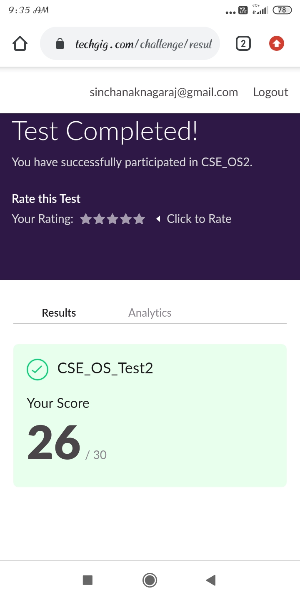

**Certification Course Summary:** **Today I started java programming in that I learnt about array in Java and flow control statement in java**

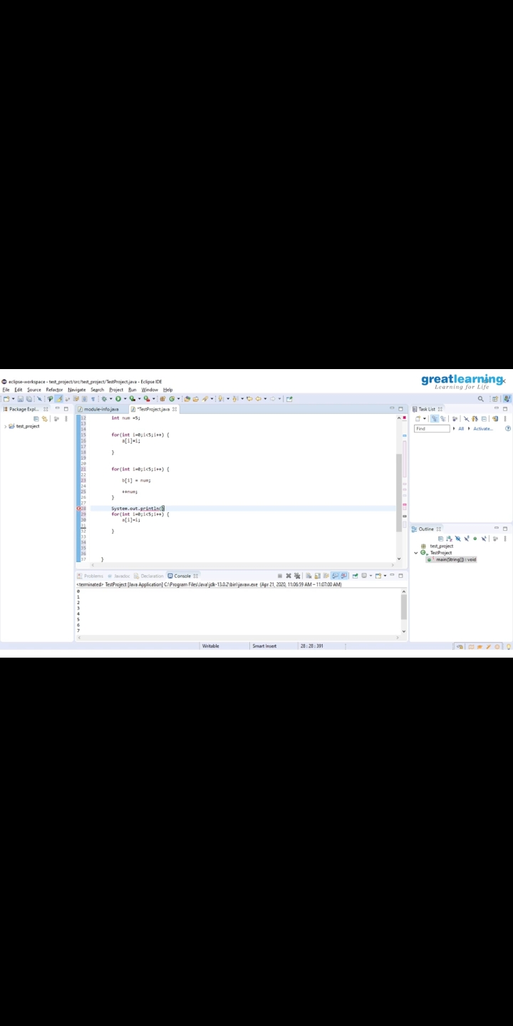

**Coding Challenges:**

Today I solved 2 coding challenge,

1. [Write a C Program to generate first N Armstrong Numbers](https://github.com/orgs/alvas-education-foundation/teams/2nd-year/discussions/87)
2. [Write a Java program to Find size of the largest ‘+’ formed by all ones in a binary matrix](https://github.com/orgs/alvas-education-foundation/teams/2nd-year/discussions/86)

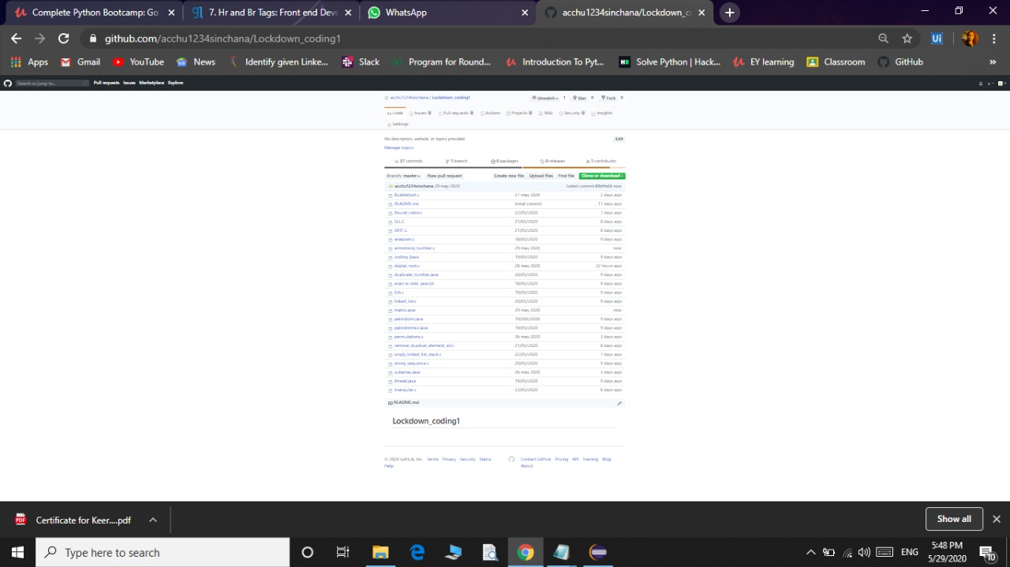

Extra Activity:

Today I attended one Quiz which is **ONLINE QUIZ ON DATA & COMPUTER COMMUNICATION NETWORK and I got 80% with certificate.**

